31.23: a) Using the phasor diagram at right we can see:
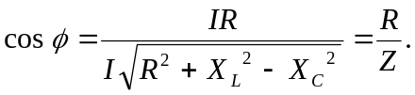
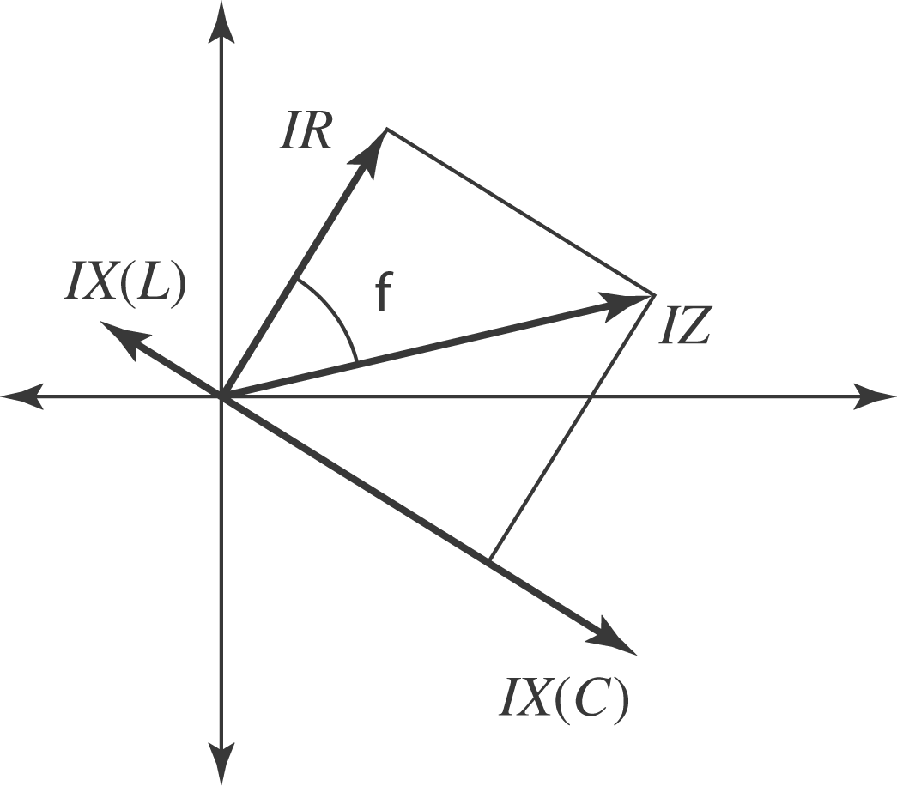
b) 